THE VALUES OF INCLUSION
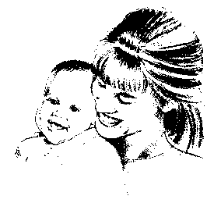
Everyone is born in
We are all born as equal citizens and part of a community, we are only later excluded.

All means all
Everyone capable of breathing, even if breathing requires support, is entitled to be included - no-one is too difficult, too old, too poor or too disabled to qualify.
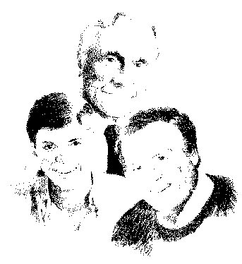
Everyone needs to be in
If people are physically excluded, they have to be physically included. Judith Snow talks about presence being the first criteria for inclusion - if you’re not there, no-one will know you’re missing.

Everyone needs to be with
Being there is necessary - but being with takes time and effort. A community is not just a locality - it is a network of connections and relationships. We have to help people be part of and belong to communities, not just be lonely residents within them or day visitors to them.
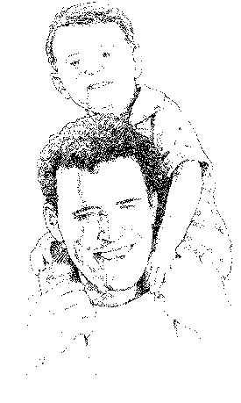
Everyone is ready
No-one has to pass a test or meet a set of criteria to be eligible - everyone is ready to be part of community now and it is community's task to find ways of including them.

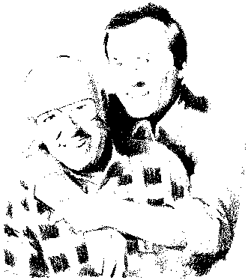
Everyone needs support - and some need more support than others
No-one is fully independent and independence isn't our goal. We are working towards inter-dependence and differing degrees and kinds of support at different times.

Everyone can communicate
Just because someone can't or won't use words to communicate doesn't mean that they don't have anything to say - everyone can communicate and we have to work harder at hearing, seeing, understanding and feeling what people are communicating to us and communicating back.


Everyone can contribute
Each person has their own gifts and strengths - and each person has a unique contribution to make. Our task is to recognise, encourage and value each person's contribution - including our own!

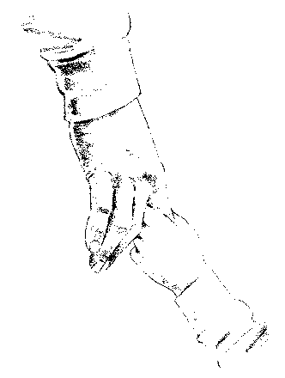
Together we are better
We do not believe the world would be a better place if everyone is the same. We are not dreaming of a world when all differences are eradicated and all disabilities are cured - we believe that diversity does bring strength and that we can all learn and grow by knowing one another.

Heather Anderson
SHS

